McDougal Geometry chapter 7 notes

7.1 Apply the Pythagorean Thm: pg. 436 #5-33 odds (skip 29)

TK#57: Pythagorean Thm: In a right triangle, (leg1)²+(leg2)²=(hyp)².
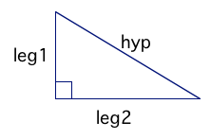

TK#58: Common Pythagorean Triples: 3,4,5;5,12,13;8,15,17;7,24,25
The previous 4 Pyth Triples and their multiples all form right triangles.

Prove Pyth Thm using the area of the square. (See bottom of page 434.)

GP 5 Leave the answer in simplified radical form.

GP 6

GP 8

Prove Pyth Thm.

7.2 Use the converse of the Pythagorean Thm, pg. 444 #15-31odds,35,36,40 (on graph paper)

Read comics to arrive the following 3 theorems.

TK#59: Converse of Pyth Thm: If (longest side)²=(short side1)²+(short side2)², then triangle is right. If c²=a²+b², then triangle ABC is right.
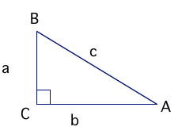

Notice that side a is opposite of angle A, side b is opposite of angle B, and side c is opposite of angle C. Lower case letters represent sides, and capital letters represent angles.

TK#60: Verify Acute Triangle Thm: If the square of the length of the longest side of a triangle is less than the sum of the squares of the lengths of the other 2 sides, then the triangle is an acute triangle. If c²<a²+b², then triangle ABC is acute.
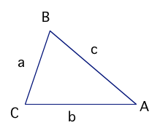

TK#61: Verify Obtuse Triangle Thm: If the square of the length of the longest side of a triangle is greater than the sum of the squares of the lengths of the other 2 sides, then the triangle is an obtuse triangle. If c²>a²+b², then triangle ABC is obtuse.
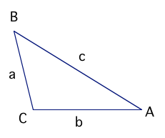

Old TK#46: Triangle Inequality Thm: The sum of the lengths of any 2 sides of a triangle is greater than the length of the third side. AB+BC>AC, AC+BC>AB, and AB+AC>BC

GP 1, 2, 4.
7.3 Use Similar Right Triangles

TK#62: Similar Right Triangles Thm: If the altitude is drawn to the hypotenuse of a right triangle, then the 3 triangles formed are similar to each other. ∆ABC~∆CBD~∆ACD.
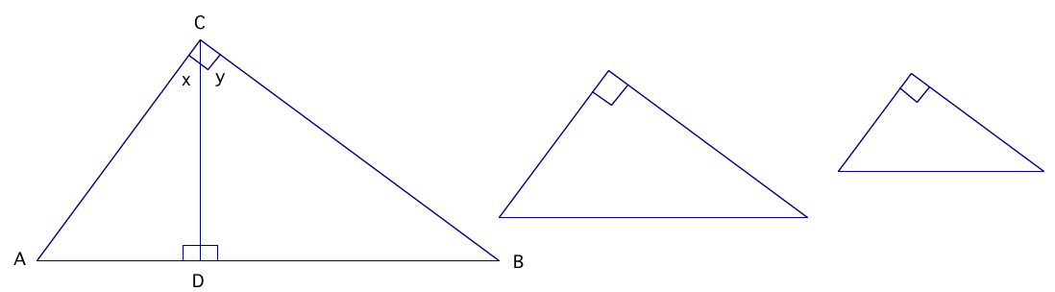

Proof of Similar Right Triangles Thm
Given: Rt ∆ABC with right $Ð\text{ACB}$ and altitude $\overline{\text{CD}}$
Prove: ∆ABC~∆CBD~∆ACD

Stmts | Reasons
1. Rt ∆ABC with right $Ð\text{ACB}$ and altitude $\overline{\text{CD}}$ | 1. Given
2. $\overline{\text{CD}}\hat{\overline{\text{AB}}}$ | 2. Def of altitude
3. $Ð\text{ADC}$ and $Ð\text{CDB}$ are right angles | 3. Def of perpendicular
4. ∆ACD and ∆CBD are right triangles with right $Ð\text{ADC}$ and $Ð\text{CDB}$ | 4. Def of right triangles
5. $Ð\text{ACB}\text{@Ð}\text{ADC}\text{@Ð}\text{CDB}$ | 5. Right Angle Congruence Thm
6. $ÐA\text{@Ð}A,ÐB\text{@Ð}B$ | 6. Reflexive prop
7. ∆ACD ~∆ABC, ∆CBD ~∆ABC | 7. AA∆~Post
8. $ÐA\text{@Ð}y,ÐB\text{@Ð}x$ | 8. Def of ~∆s: corr angles of ~∆s are $@$
9. ∆ACD~∆CBD | 9. AA∆~Post
QED

In the figure above, since ∆ACD~∆CBD, it follows that $\frac{\text{BD}}{\text{CD}}=\frac{\text{CD}}{\text{AD}}$ by Def of ~∆s: corr sides of ~∆s are proportional. This result is called Geometric Mean (Altitude) Thm.

In the figure above, since ∆ACD~∆ABC and ∆CBD ~∆ABC, it follows that $\frac{\text{AB}}{\text{CB}}=\frac{\text{CB}}{\text{DB}},\frac{\text{AB}}{\text{AC}}=\frac{\text{AC}}{\text{AD}}$ by Def of ~∆s: corr sides of ~∆s are proportional. This result is called Geometric Mean (Leg) Thm.

Example 1
Given : Rt ∆RST with altitude $\overline{\text{SU}}$, RU=10 units, SU=8 units
Find: TU

Example 2
Given : Rt ∆ABC with altitude $\overline{\text{CD}}$, AB=18m, DB=6m
Find: CD

Example 3
Given :
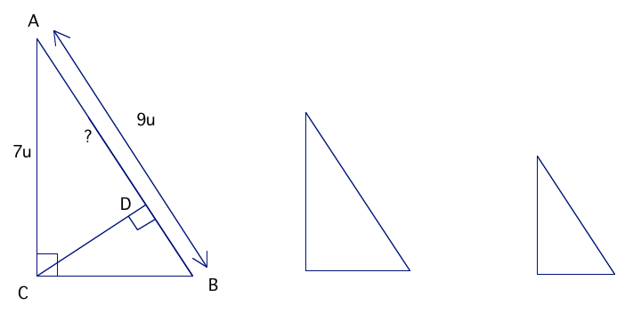
Find: AD

Exercises: use a separate sheet of paper to do #1-12.

In right ∆RTS, $Ð\text{RTS}$ is a right angle and $\overline{\text{TU}}$ is altitude. Find the indicated lengths.

- RU=8, TU=4, US=? 4. RS=32, RT=24, RU=?
- RU=27, TU=?, US=3 5. RS=?, US=4, TS=6
- RU=?, TU=2, US=1 6. RS=16, RU=8, RT=?

In #7-12, use the following diagram to find the missing lengths.
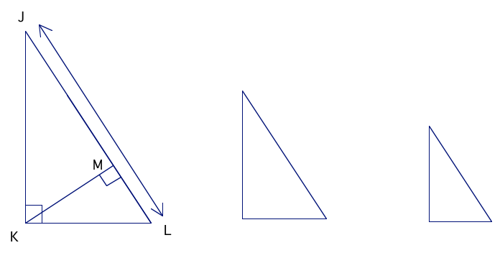

7. JL=20, ML=4, KM=? 10. JL=18, KL=12, ML=?
8. JL=?, JM=4, JK=6 11. JL=8, JK=?, JM=2
9. JL=25, JM=5, KM=? 12. JL=20, KL=?, ML=15

Bonus: Given: $\overline{\text{BC}}\hat{\overline{\text{AC}}},\overline{\text{CE}}\hat{\overline{\text{AB},}}\overline{\text{ED}}\hat{\overline{\text{AC}}}$
Prove: ∆BEC~∆CDE
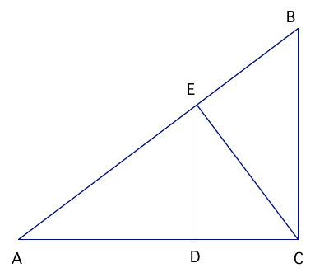

_____ In class: go over a different pf of Pyth Thm on pg 455 #32. Quiz rev pg 447#1-9 all and pg 464#1-5 all and review the 2 proofs of Pyth Thm
_____ Quiz or common assessment
7.4 Special Right Triangles

TK#63: 45⁰-45⁰-90⁰ Triangle Thm: In a 45⁰-45⁰-90⁰ triangle, the hypotenuse is $\sqrt{2}$times as long as each leg.
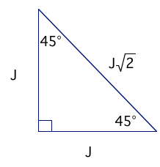

TK#64: 30⁰-60⁰-90⁰ Triangle Thm: In a 30⁰-60⁰-90⁰ triangle, the hypotenuse is twice as long as the shorter leg, and the longer leg is $\sqrt{3}$ times as long as the shorter leg.
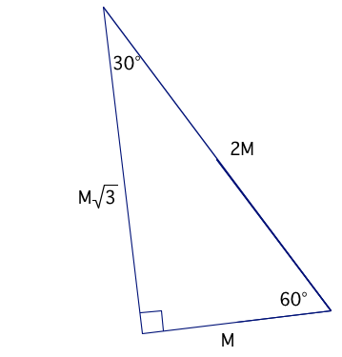

GP 2-6.

If time: Prove TK#63,64.

7.4 one day hwk: pg 461 #1-25 odds, 28-32E. Bring ruler, protractor, and calculator tomorrow. Or 7.4 day 1 hwk: pg 461 #1-25 odds.
7.4 day 2 hwk: pg 462 #14-32E (skip 26)
7.5 Apply the tangent ratio, pg. 469 # 1-25 odds, 32-36E

Do Activity Right Triangle Ratio from the top of page 466 at the back of this page. Need ruler, protractor, and calculator.

From the previous activity, we noticed that the ratio of the lengths of the legs in similar right triangles is constant. Since the ratio of $\frac{{\text{opposite}}_{\text{leg}}}{{\text{adjacent}}_{\text{leg}}}$ in a right triangle is constant for a given angle measure, we will call $\frac{{\text{opposite}}_{\text{leg}}}{{\text{adjacent}}_{\text{leg}}}$ the tangent ratio. Also, the tangent ratio has to be constant since on a single line, the slope should be the same regardless of which 2 points we use.
$$\text{tan}A=\frac{{\text{opposite}}_{{\text{leg}}_{{\text{from}}_{ÐA}}}}{{\text{adjacent}}_{{\text{leg}}_{{\text{to}}_{ÐA}}}}=\frac{\text{BC}}{\text{CA}}$$
$$\text{tan}B=\frac{{\text{opposite}}_{{\text{leg}}_{{\text{from}}_{ÐB}}}}{{\text{adjacent}}_{{\text{leg}}_{{\text{to}}_{ÐB}}}}=\frac{\text{CA}}{\text{BC}}$$
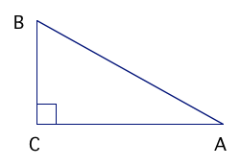

GP 2-5
7.6 Apply the sine and cosine ratios

TK#65: Trig ratios
$\text{sin}A=\frac{{\text{opp}}_{{\text{leg}}_{{\text{from}}_{ÐA}}}}{\text{hyp}}=\frac{\text{BC}}{\text{AB}}$, $\text{sin}B=\frac{{\text{opp}}_{{\text{leg}}_{{\text{from}}_{ÐB}}}}{\text{hyp}}=\frac{\text{CA}}{\text{AB}}$
$\text{cos}A=\frac{{\text{adj}}_{{\text{leg}}_{{\text{from}}_{ÐA}}}}{\text{hyp}}=\frac{\text{CA}}{\text{AB}}$, $\text{cos}B=\frac{{\text{adj}}_{{\text{leg}}_{{\text{from}}_{ÐB}}}}{\text{hyp}}=\frac{\text{BC}}{\text{AB}}$

$\text{tan}A=\frac{{\text{opp}}_{{\text{leg}}_{{\text{from}}_{ÐA}}}}{{\text{adj}}_{{\text{leg}}_{{\text{to}}_{ÐA}}}}=\frac{\text{BC}}{\text{CA}}$, $\text{tan}B=\frac{{\text{opp}}_{{\text{leg}}_{{\text{from}}_{ÐB}}}}{{\text{adj}}_{{\text{leg}}_{{\text{to}}_{ÐB}}}}=\frac{\text{CA}}{\text{BC}}$

TK#66: Angles of elevation and depression
Angle of elevation=$α$=angle formed from horizontal up to the line of sight
Angle of depression=$β$=angle formed from horizontal down to the line of sight
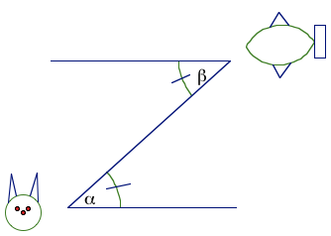

Using GP4, find sinR, sinS, cosR, cosS, tanR, tanS. Write each ratio as a fraction and decimal (4 decimal places). (Use the back of this page.)

Redo example 3 without using sin35⁰.

Do GP 6.
Notice where the angle of elevation is!!!

If time: do GP 8. Leave answers in exact form (simplified square root form, NO decimals!)

7.6 one day hwk: pg 477 #1-29 odds, 34,36 or
7.6 day 1 hwk: pg 477 #1-29 odds
7.6 day 2 hwk: pg 477 #16-28E,34,36
7.7 Solve right triangles

If tanA=x, then we can apply the arc tangent function or inverse tangent to both sides to get tan⁻¹(tanA)=tan⁻¹x. Since tan⁻¹ and tan are inverses and undo each other, we are left with A= tan⁻¹x. Using the symmetric property, tan⁻¹x =A. Therefore, if tanA=x, then tan⁻¹x =A.

Using similar reasonings as above: If sinA=y, then sin⁻¹ y=A.
Also: If cosA=z, then cos⁻¹ z=A.

Solving a right triangle means find all the missing sides and angles.

GP 2-4.

___________7.7 one day hwk: pg 485#1-29 odds,34-42E or 7.7 day 1 hwk: pg 485#1-29 odds. Print out ch 8 notes.
__________7.7 day 2 hwk: pg 486#20-30E, 34-42E. Print out ch 8 notes.
Law of Sines and Law of Cosines, pg 491#1-7 all and Special Right Triangles Review Sheet

TK#67: Whereas the 3 trig ratios of sine, cosine, and tangent require right triangles, the Law of Sines ($\frac{\text{sin}A}{a}=\frac{\text{sin}B}{b}=\frac{\text{sin}C}{c}$) and the Law of Cosines (a²=b²+c²-2bcCosA or
b²=a²+c²-2acCosB or c²=a²+b²-2abCosC) work with any type of triangles: right, acute, or obtuse.

Law of Sines was proved on 7.7#42.

Example 1: How much closer does Halia live to school than Eden?
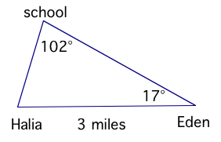

Example 2: Find B in ∆ABC when a=11cm, b=17cm, c=19cm.

(If time) Prove the Law of Cosines by the back of the page.

________Turn in ch 8 notes. Ch 7 group quiz. Hwk: Practice Test pg. 498 #1-17 all (skip16)
________Correct group quiz
________Turn in TK#1-67. Ch 7 Test.

